**TMP1133 - MINI IT PROJECTS**

**(Foundation in Information Technology)**

**MMU Little Helper**

**Lim Wei Xian – 1231102298**

**Sim Lui An – 1231202153**

**Lew Yan Li – 1231101285**

**Goh Dilei – 1231200740**

**Supervisor:** **Madam. Robiatun Adawiah Binti Ahmad Kushairi**

**Faculty of Information Science & Technology**

**Multimedia University**

**Trimester: July/August 2024 (Term 2420)**

|  |  |  |
| --- | --- | --- |
| Session | : | Trimester July/August 2024 (Term 2420) |
| Supervisor | : | Madam Robiatun Adawiah Binti Ahmad Kushairi |
| Project Title | : | MMU Little Helper |

|  |  |  |  |  |
| --- | --- | --- | --- | --- |
| **OVERALL EVALUATION** | | | | |
| **Evaluation Component** | | | **Marks** | |
| 1. **Project Proposal (10%)** | | | **/16** |  |
| 1. **Preliminary Report (20%)** | | | **/40** |  |
| 1. **Project Design and Prototype (30%)** | | | **/20** |  |
| 1. **Final Report (30%)** | | | **/24** |  |
| 1. **Presentation (10%)** | | | | |
| Student ID: 1231102298  Name: Lim Wei Xian | Student ID:  1231202153  Name: Sim Lui An | Student ID: 1231101285  Name: Lew Yan Li | Student ID: 1231200740  Name: Goh Dilei | Student ID:  Name: |
|  |  |  |  |  |
| **TOTAL MARKS** | | | | |
|  |  |  |  |  |

__________________________

Supervisor’s Signature & Stamp

To be completed by Supervisor:

|  |  |  |  |  |  |  |
| --- | --- | --- | --- | --- | --- | --- |
| **Project Proposal (10%)** | | | | | | |
| **No** | **Criteria** | **Excellent (4 points)** | **Good (3 points)** | **Fair (2 points)** | **Poor (1 point)** | **Mark** |
| **1** | **Clarity** | Proposal is exceptionally clear and concise, with detailed and clear explanations of objectives, methods, and expected outcomes. | Proposal is clear and well-organised, with detailed and clear explanations, though some minor aspects may be less detailed. | Proposal is somewhat clear, but lacks detail or clarity in several areas, making it difficult to understand. | Proposal is unclear and unorganised, with incomplete explanations. |  |
| **2** | **Problem Statement** | Clearly defines the problem with thorough background information. Demonstrates a strong understanding and relevance. | Defines the problem with adequate background information. Shows good understanding and relevance. | Defines the problem but lacks depth in background information. Understanding and relevance are somewhat evident. | Define the problem with minimal or no background information. Lacks understanding and relevance. |  |
| **3** | **Creativity/Ambition** | The proposal presents an innovative and ambitious approach. Shows an original idea and potential for significant impact. | The proposal is creative and ambitious, with some originality. Shows potential for a significant impact. | The proposal has some creative elements but lacks ambition. It has limited originality and a moderate impact potential. | The proposal is not creative or ambitious. It lacks originality and has minimal potential for impact. |  |
| **4** | **Structure and Flow** | Information is organised logically with smooth transitions. Proposal is easy to follow and well-organised. | Information is generally organised logically. Proposal is generally straightforward with a good structure. | Information is somewhat organised, but with an obvious lack of logic and flow. The structure is uneven, making it difficult to follow. | Information is disorganised with poor flow. Proposal is difficult to follow and lacks clarity. |  |
| **TOTAL** | | | | | | **/16** |
| **Normalised Mark (10%)** | | | | | |  |

To be completed by Supervisor:

|  |  |  |  |  |  |  |
| --- | --- | --- | --- | --- | --- | --- |
| **Project Design and Prototype (30%)** | | | | | | |
| **No** | **Criteria** | **Excellent (4 points)** | **Good (3 points)** | **Fair (2 points)** | **Poor (1 point)** | **Mark** |
| **1** | **Interface / Layout (UI)** | The interface is very intuitive and user-friendly with an optimal layout. | The interface is mostly intuitive with an effective layout. | The interface is quite intuitive, but the layout may require adjustments. | The interface is confusing, and the layout is not efficient. |  |
| **2** | **Creativity** | Displays outstanding creativity with unique and innovative design elements. | Shows good creativity with some original and effective designs. | Demonstrates moderate creativity with a few unique or original features. | It lacks creativity with minimal or no unique design elements. |  |
| **3** | **Multimedia / Input / Output** | Excellent integration of multimedia with effective input/output. | Good use of multimedia with mostly clear and effective input/output. | Some use of multimedia; input/output are quite clear. | Poor integration of multimedia with unclear or ineffective input/output. |  |
| **4** | **System Efficiency** | Highly efficient system with optimal performance and quick response times. | Generally efficient with minor performance issues or slight delays. | Some efficiency issues; obvious delays or performance issues. | Inefficient system with frequent delays or performance issues. |  |
| **5** | **Project Continuity** | Excellent continuity with a clear, logical plan and consistent development. | Good continuity with a clear plan and consistent development. | Some continuity issues: plan is somewhat clear, but development may vary. | It lacks continuity with an unclear plan and inconsistent development. |  |
| **TOTAL** | | | | | | **/20** |
| **Normalised Mark (30%)** | | | | | |  |

To be completed by Supervisor:

|  |  |  |  |  |  |  |
| --- | --- | --- | --- | --- | --- | --- |
| **Final Report (30%)** | | | | | | |
| **No** | **Criteria** | **Excellent (4 points)** | **Good (3 points)** | **Fair (2 points)** | **Poor (1 point)** | **Mark** |
| **1** | **Formatting** | The document is professionally formatted with consistent fonts, sizes, headings, and spacing. All sections are clearly indicated. | The document is well-formatted with minor errors in fonts, sizes, headings, or spacing. Sections are mostly clear. | The document has several formatting issues, such as inconsistent fonts, sizes, headings, or spacing. Some sections are unclear. | The document is poorly formatted with numerous inconsistencies and unclear sections. |  |
| **2** | **User Friendliness** | The document’s layout is intuitive and allows users to locate information quickly and efficiently without any confusion. | The document’s layout is generally intuitive, with minor improvements necessary to reduce user confusion. | The document’s layout is somewhat intuitive, but users may have difficulty finding information. | The document’s layout is confusing, making it difficult for users to find information. |  |
| **3** | **System Analysis** | Thorough analysis with detailed explanation of the system components, architecture, and data flow. Includes clear diagrams and charts. | Good analysis with adequate explanation on the system components, architecture, and data flow. Includes diagrams and charts. | Basic analysis with limited explanation on the system components, architecture, and data flow. The diagrams and charts are minimal. | Lacking analysis with poor or no explanations of the system components, architecture, and data flow. No diagrams and charts. |  |
| **4** | **User Manual** | A comprehensive manual with clear instructions, screenshots, and troubleshooting instructions. Users can understand and follow. | Good manual with clear instructions and a few screenshots. Minor areas may require clarification. | A basic manual with minimal instructions and a few screenshots. Users may be unable to understand and follow. | Unreliable manual with unclear or missing instructions and no screenshots. Users find it difficult to follow. |  |
| **5** | **Completeness** | All required sections are included and thoroughly covered. Additional relevant information is provided. | Most required sections are included and adequately covered. Additional information is provided. | Some required sections are missing or inadequately covered. There is few additional information provided. | Many required sections are missing or inadequately covered. No additional information is provided. |  |
| **6** | **Neatness** | The report is very neat, well-organised, and free of errors. | The report is neat and organised with minimal errors. | The report is somewhat organised and has several errors. | The report is unorganised and has numerous errors. |  |
| **TOTAL** | | | | | | **/24** |
| **Normalised Mark (30%)** | | | | | |  |

To be completed by Supervisor:

|  |  |  |  |  |  |  |  |  |  |  |  |
| --- | --- | --- | --- | --- | --- | --- | --- | --- | --- | --- | --- |
| **Presentation (10%)** | | | | | | | | | | | |
| **No** | **Criteria** | | **Excellent (4 points)** | | **Good (3 points)** | | **Fair (2 points)** | | **Poor (1 point)** | | **Mark** |
| **1** | **Clarity / Organisation** | | Presentation is clear, relevant, and well-organised; ideas flow rationally and are easy to follow. | | Presentation is generally clear and relevant; some minor organisation issues, but ideas are generally clear. | | Presentation is somewhat concise and relevant; organisation issues occasionally make ideas difficult to follow. | | Presentation lacks clarity and relevance; the lack of organisation makes ideas difficult to follow. | |  |
| **2** | **Audience Engagement** | | Presenter effectively engages the audience, maintains their interest, and encourages participation. | | Presenter engages the audience and maintains interest; minor issues in encouraging participation. | | Presenter occasionally engages the audience and audience occasionally lost interest. | | Presenter does not engage the audience; does not maintain interest or encourage participation. | |  |
| **3** | **Entrepreneurship** | | Presentation demonstrates an exceptional entrepreneurial spirit; ideas are highly innovative and demonstrate significant potential. | | Presentation demonstrates a strong entrepreneurial spirit; ideas are innovative and demonstrate potential. | | Presentation demonstrates some entrepreneurial spirit; ideas are somewhat innovative. | | The presentation lacks entrepreneurial spirit; ideas are not innovative or well-developed. | |  |
| **4** | **Slide Design** | | Slides are visually appealing, with a consistent and professional design; effectively utilise visuals and texts. | | Slides are generally visually appealing; minor inconsistencies in design; visuals and text utilised effectively. | | Slides are somewhat visually appealing; some shortcomings in design; visuals and text usage could be improved. | | Slides lack visual appeal; inadequate design; poor use of visuals and text. | |  |
| **5** | **Response to question** | | Responses are delivered in a professional manner; the presenter has a strong understanding of the material. | | Responses are delivered with confidence; the presenter has a good understanding of the material. | | Responses are delivered with some confidence; the presenter has a basic understanding of the material. | | Responses are delivered with lack of confidence; the presenter lacks understanding of the material. | |  |
|  | | **Student 1** | | **Student 2** | | **Student 3** | | **Student 4** | | **Student 5** | |
| **TOTAL** | | **/20** | | **/20** | | **/20** | | **/20** | | **/20** | |
| **Normalised Mark (10%)** | |  | |  | |  | |  | |  | |



**Supervisor’s Signature & Stampop of Form**

**Co-Supervisor’s Signature & Stamp**

# Table of Contents

Table of Contents i

Chapter 1: Introduction 1

1.1 Objective 1

1.2 Problem Statement 1

Chapter 2: Background and System Planning 2

2.1 Scope/Domain 2

2.2 Feasibility studies 2

2.2.1 Operational feasibility 3

2.2.2 Technical feasibility 3

2.2.3 Economic feasibility 4

2.2.4 Schedule feasibility 4

Chapter 3: System Analysis and Design 6

3.1 Site Map 6

3.1 Storyboard 7

Chapter 4: System Implementation 13

4.1 Input Screens 13

4.2 Output Screens 15

4.3 User manual 16

Chapter 5: Conclusion 17

Appendices: 18

Appendix A - References 18

Appendix B - Declaration Form 18

Appendix C - Meeting Log 18

Appendix D - Group Information 18

# Chapter 1: Introduction

Every semester, a lot of fresh students get into our university. Since they are new to our university, they might not be familiar with everything at MMU University. Hence, we hope to create a user-friendly website to help them solve their problems on our website. With our website, students can roughly search their school fees by giving the information to our website. Besides that, our website provides a calculator to check their CGPA. Furthermore, our website can accumulate their attendance percentage.

## 1.1 Objective

Further, the main aim of this study is to develop a user-friendly website to streamline your studies with precise financial and performance insight. In connection, specific objectives are as follows:

* To enable students to easily access and view relevant tuition information for their chosen courses.
* To integrate a CGPA calculator on the website to help students understand the level of effort required to achieve academic goals.
* To implement an attendance calculator on the platform to help users monitor attendance, and communities are included in the barring list.

## 1.2 Problem Statement

We find that students face many problems in university life. Academically, students will want to know if their CGPA passes or meets their requirements for themselves. In addition, many students encounter difficulties in financial management. They often realize that they do not have enough pocket money, but they do not know where they spend the money. To address these issues, we decided to develop a user-friendly website specifically tailored for new students. The platform will enable students to calculate tuition fees based on the courses they choose, and the information provided. Additionally, we plan to integrate the CGPA Calculator into the website to help students understand the level of effort required to achieve their academic goals. Finally, lecturers may forget to update students' attendance. So, we are considering implementing an attendance calculator on the platform so that students can closely monitor their attendance and avoid being placed on the barring list.

# Chapter 2: Background and System Planning

The website that we wanted to develop helps fresh students solve their problems. We want to create a user-friendly website to guide fresh students and help them solve their problems. However, our university provides an app called "MMU Mobile" that is similar to our website, but it provides some technical issues. For example, it needs to use an older version of Android to install it and doesn't provide an IOS user to install it. That is the reason we decided to create an enhanced version that is more usable by itself.

We believe this website has a certain value and is marketable because fresh students desire a website that can help them. Therefore, that will be the value of our website. Furthermore, our target audience is fresh students. So, we designed our website to be very easy to use and have a user-friendly interface. We expect that fresh students can accept our website because most of the fresh students nowadays have some troubles so they can use this website to help them.

## 2.1 Scope/Domain

We covered a lot of areas when doing this project, such as pre-project investigation, feasibility discussion, and work allocation. In addition, we also learned a lot of skills for this project, such as HTML, CSS, and JavaScript, and combined them with the multimedia skills we learned before to design web pages and perform related functions on the web pages. We also helped each other find how to optimize the calculation code and search for information on the Internet. We also discussed many problems with the lecturer and got solutions. During the development process, we also used each other's knowledge and implemented it in this project.

## 2.2 Feasibility studies

We compared some tools commonly used by MMU students and compared them with MMU Little Helper in various aspects.

**Table 2.2: Comparison between our website and other websites**

|  |  |  |  |  |
| --- | --- | --- | --- | --- |
| **Platform** | **Comparison** | | | |
| **Interface design** | **Entry method** | **Functional** | **Source to get it** |
| **MMU Little Helper** | Used many colourful pictures and icons | No process and login required | Include CGPA /School Fees/ attendance calculator, FAQs and qr code scanner | Can search through Internet |
| **CLIC** | Many texts and lack of pictures | Required account and password to login and submit OTP | The school's official website, which have the most functions for students to use. | Can search through Internet |
| **MMU Mobile** | Simple interface | Required account and password to login | Have several functions but some functions have not been updated | Difficult to find application |

### 2.2.1 Operational feasibility

We compared the websites and software that we can find currently to provide functions for MMU students, and we found that there is no one with a simple interface and suitable functions. So, we decided to develop MMU Little Helper to fill this gap. Our website is suitable for providing calculation services to students, including CGPA, attendance rate and tuition fees. This can attract students with the need to use our website more conveniently.

### 2.2.2 Technical feasibility

During the development process, we found that web design websites (such as wix.com) could not help us provide the functions we wanted, so we decided to learn web programming languages ​​(such as HTML, CSS and JavaScript) online and use them to develop web pages and related functions. In addition, we also searched for the calculation formula of CGPA to ensure that our website would not have related errors.

In terms of design, we also used a lot of knowledge, and techniques learned in multimedia courses and applied them to the design of the website interface to ensure that users have a good visual experience.

### 2.2.3 Economic feasibility

Creating a website using paid content to get full features bears a burden on university students. Without using paid content tools such as WIX, Visual Studio Code is a better choice for us. It is free for all users. Besides tools, hosting fees are another economic issue.

Cost Considerations:

* Ongoing Maintenance:

Annual maintenance costs include hosting, domain registration, software updates, and content management. These costs typically range from RM50 to RM200 per month, depending on the website's complexity.

### 2.2.4 Schedule feasibility

This table presents the timeline indicating the commencement and completion dates for various tasks:

1) Project proposal

2) System analysis and design

3) Development & testing

4) Presentation & final report.

**Table 2.2.4: Gantt Chart**

|  |  |  |  |  |  |  |  |
| --- | --- | --- | --- | --- | --- | --- | --- |
|  | WEEK1 | WEEK2 | WEEK3 | WEEK4 | WEEK5 | WEEK6 | WEEK7 |
| Confirm inspiration and communicate with lecture |  |  |  |  |  |  |  |
| Confirm content and come up with an outline |  |  |  |  |  |  |  |
| Collect data and study the development process |  |  |  |  |  |  |  |
| Test the function and fix bugs |  |  |  |  |  |  |  |
| Prepare for the Presentation |  |  |  |  |  |  |  |
| Submit the final work and complete the present |  |  |  |  |  |  |  |

# Chapter 3: System Analysis and Design

Our website can accurately calculate CGPA, attendance and tuition fees for students. We have integrated all the functions into one page so that students can easily find the functions of the website and use them. The simple page and direct usage method can attract users to use our website.

We will use storyboards and sitemaps as drafts for our website designs. They will allow us to better design the functions and effects between each web page. They will also allow designers and developers to communicate better. Sitemaps can help us sort out how each website works, and storyboards can show the content and structure we have planned for the project. We can also make modifications during the development cycle to facilitate producing better works.

## 3.1 Site Map

This sitemap shows that our website is a non-linear website so that users can navigate freely through the content of the project. They are free to jump to any page they like. Besides, all functions of our website and the way to navigate them are written on the site map.

**Figure 3.1: Structure Chart.**

## 3.1 Storyboard

Storyboard No. 1

Title: Home Page

|  |  |  |
| --- | --- | --- |
| SCREEN DESIGN | INTERFACES INSTRUCTION | ACTION/SCRIPT |
|  | B1: Button-Home  B2: Button-Attendance  B3: Button-CGPA/GPA  B4: Button-More  B5: Button-Click here  G1: Graphic-Picture  G2: Graphic-Background  G3: Graphic-Picture  G4: Graphic-Picture  G5: Graphic-Picture  G6：Graphic-Picture  T1: Text-Website Name  T2; Text-Tittle  T3- Text-Details  T4; Text-Tittle  T5- Text-Details  T6- Text-Details  T7- Text-Details  T8- Text-Details  T9- Text-Footer | |  | | --- | | B1: Go to page “Home”  B2: Go to page “Attendance”  B3: Go to page “CGPA”  B4: Open dropdown menu | |

Storyboard No. 2

Title: CGPA/GPA

|  |  |  |
| --- | --- | --- |
| SCREEN DESIGN | INTERFACES INSTRUCTION | ACTION/SCRIPT |
|  | B1: Button-Home  B2: Button-Attendance  B3: Button-CGPA/GPA  B4: Button-More  B5: Button-Click here  T10: Text-Tittle  T11: Text- Details  T12: Text- Details  T13: Text- Details  T14: Text- Details  T15: Text- Details  T16: Text- Details  T17: Text- Details  T18: Text- Details  T19: Text- Details  T9: Text-Footer    G7: Graphics-Background    I1: Input-Previous CGPA  I2: Input-Previous Credit Hour  I3: Input-Course Name  I4: Input-Credit Hour  I5: Input-Grade    O1: Output-Result  O2: Output-Result  O3: Output-Result  O4: Output-Result | B1: Go to page “Home”  B2: Go to page “Attendance”  B3: Go to page “CGPA”  B4: Open dropdown menu |

Storyboard No. 3

Title: Attendance Calculator

|  |  |  |
| --- | --- | --- |
| SCREEN DESIGN | INTERFACES INSTRUCTION | ACTION/SCRIPT |
|  | B1: Button-Home  B2: Button-Attendance  B3: Button-CGPA/GPA  B4: Button-More  B5: Button-Click here  B6: Button-Add  B7: Button-Minus  B8: Button-Add  B9: Button-Minus  B10: Button-Add  B11: Button-Minus  T20: Text-Main tittle  T21: Text-Details T22: Text-Details  T23: Text-Details  T24: Text-Details  T9: Text-Footer  G8: Graphics-Background  I6: Input-Class attended  I7: Input-Total Classes  I8: Input-Percentage Required  O5: Output-Result  06: Output-Result  07: Output-Result | B1: Go to page “Home”  B2: Go to page “Attendance”  B3: Go to page “CGPA”  B4: Open dropdown menu  B6: Button-Add  B7: Button-Minus  B8: Button-Add  B9: Button-Minus  B10: Button-Add  B11: Button-Minus |

Storyboard No. 4

Title: School Fees

|  |  |  |
| --- | --- | --- |
| SCREEN DESIGN | INTERFACES INSTRUCTION | ACTION/SCRIPT |
|  | B1: Button-Home  B2: Button-Attendance  B3: Button-CGPA/GPA  B4: Button-More  B5: Button-Click here  B12: Button-Expansion  B13: Button- Expansion  B14: Button- Expansion  B15: Button- Expansion  T25: Text-Main tittle  T26: Text-Descriptions  T27: Text-Details  T28: Text-Details  T29: Text-Details  T30: Text-Details  T9: Text-Footer  G9: Graphics-Background  O7: Output-Result  I9: Input-Select Field  I10: Input-Faculty  I11: Input-Programme  I12: Input-PTPTN Loan | B1: Go to page “Home”  B2: Go to page “Attendance”  B3: Go to page “CGPA”  B4: Open dropdown menu  B12: Expansion  B13: Expansion  B14: Expansion  B15: Expansion |

Storyboard No. 5

Title: FAQ

|  |  |  |
| --- | --- | --- |
| SCREEN DESIGN | INTERFACES INSTRUCTION | ACTION/SCRIPT |
|  | B1: Button-Home  B2: Button-Attendance  B3: Button-CGPA/GPA  B4: Button-More  B5: Button-Click here  B16: Button-Show  B17: Button-Show  B18: Button-Show  B19: Button-Show  B20: Button-Show  B21: Button-Show  B22: Button-Show  T31: Text-Main Tittle  T32: Text-Question  T33: Text-Answer  T34: Text-Question  T35: Text-Answer  T36: Text-Question  T37: Text-Answer  T38: Text-Question  T39: Text-Answer  T40: Text-Question  T41: Text-Answer  T42 Text-Question  T43: Text-Answer  T44: Text-Question  T45: Text-Answer  T9: Text-Footer | B1: Go to page “Home”  B2: Go to page “Attendance”  B3: Go to page “CGPA”  B4: Open dropdown menu  B16: Show answer  B17: Show answer  B18: Show answer  B19: Show answer  B20: Show answer  B21: Show answer  B22: Show answer |

Storyboard No.6

Tittle: QR Scanner

|  |  |  |
| --- | --- | --- |
| SCREEN DESIGN | INTERFACES INSTRUCTION | ACTION/SCRIPT |
|  | B1: Button-Home  B2: Button-Attendance  B3: Button-CGPA/GPA  B4: Button-More  B5: Button-Click here  B23: Button-Use camera  I13: Input- Choose Image  G10: Graphics-Image  T47: Text-Details  T9: Text-Footer | B1: Go to page “Home”  B2: Go to page “Attendance”  B3: Go to page “CGPA”  B4: Open dropdown menu  B23: Request camera |

# Chapter 4: System Implementation

We will show our system implementation of MMU Little Helper. We are using Visual Studio code for our coding editor because it has free, extensible, and highly customizable with industry-leading features.

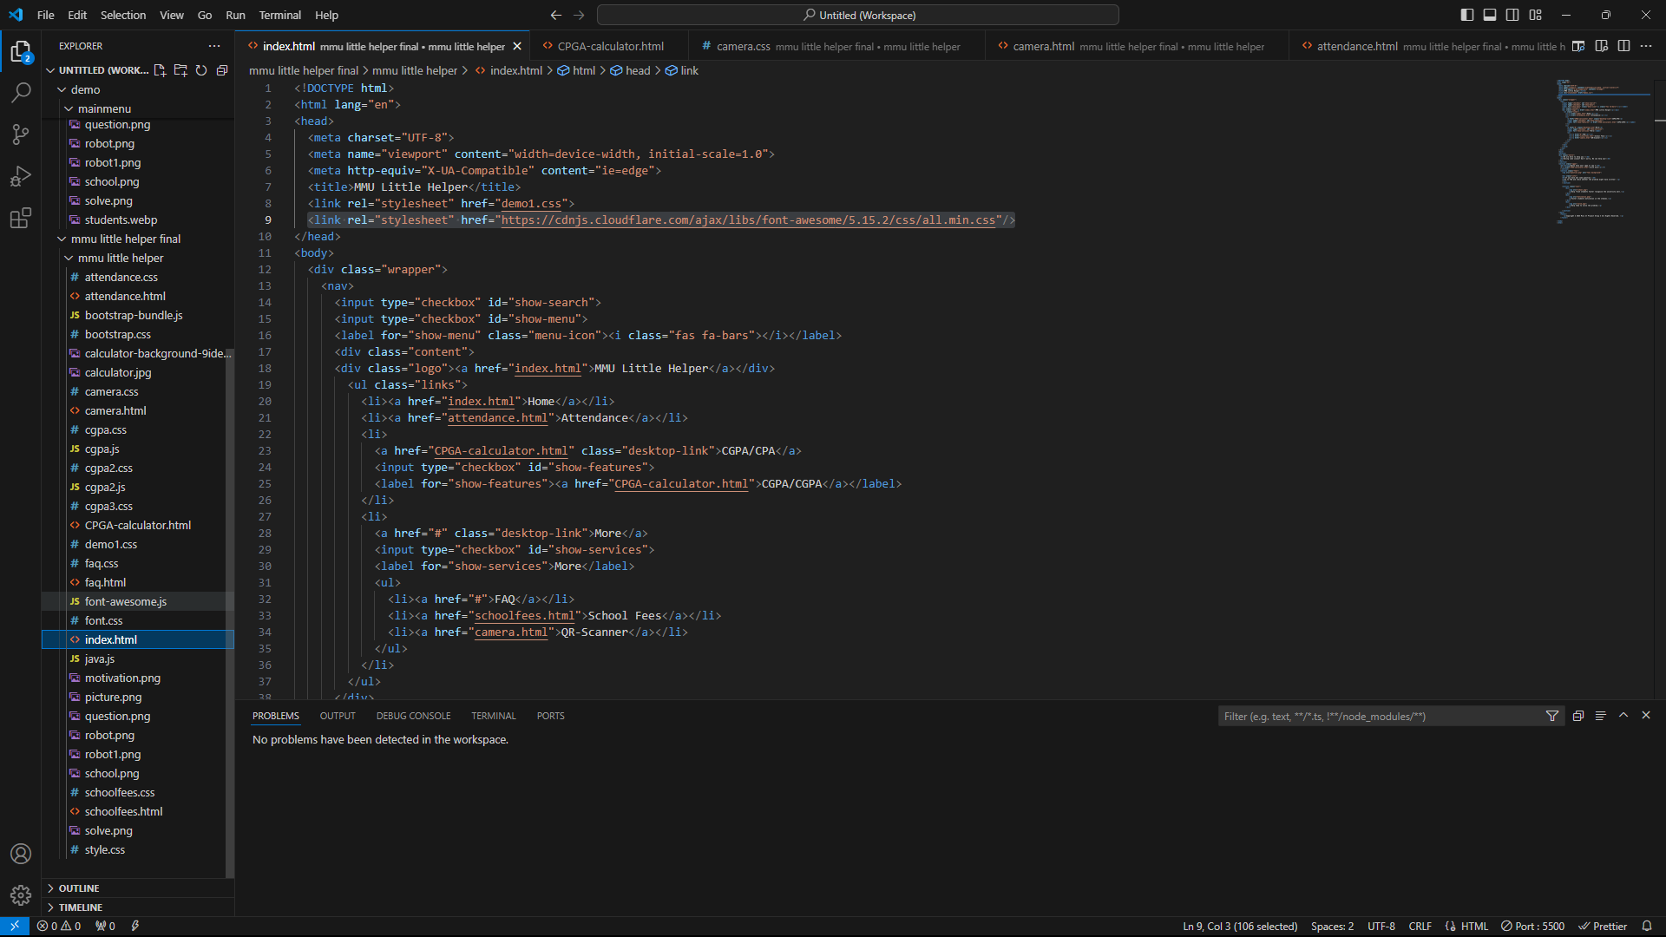

**Figure 4.0.1: Visual Studio Code platform**

GPA is the average grade point of a student for a particular trimester computed by dividing the Total Grade Points (TGP) by the Total Credit Hours (TCH). We import the formula into the calculator.

**Figure 4.0.2: Formula of GPA**

CGPA is the average cumulative point equivalent of a student from the beginning of trimester computed by dividing the Cumulative Total Grade Points (CTGP) by the Cumulative Total Credit Hours (CTCH). We also import this formula into our calculator. We also implement our calculator by following the grading schemes below.

**Figure 4.0.3: Formula of CGPA**

**Figure 4.0.4: Grading schemes of MMU**

We made our attendance percentage calculator through a website called Calconic. The calculation of attendance percentage will follow the formula below. For the classes needed to attend, there will be attendance percentage divided by hundred then multiply with the total classes.

**Figure 4.0.5: Formula of calculate attendance percentage**

**Figure 4.0.6: Formula of calculate required classes**

## 4.1 Input Screens

This is the input of Attendance Percentage Calculator. It provides users with key in information of their classes attended, total classes and percentage required to calculate their attendance.

**Figure 4.1.1: Input Screen of attendance percentage calculator**

This is the input of GPA & CGPA Calculator. Users enter their current CGPA, credit hours completed, course, credit hours and the grades to calculate.

**Figure 4.1.2: Input screen of GPA & CGPA Calculator**

This is the input of MMU School Fees Calculator. Users need to select their field, faculty, programme and PTPTN loan to get the amount of the fees.

**Figure 4.1.3: Input screen of MMU school fees calculator**

This is the input of QR Code Scanner. It required users’ camera or gallery to capture and load the QR code.

**Figure 4.1.4 & Figure 4.1.5: Input Screen of QR code scanner**

## 4.2 Output Screens

This is the output of the Attendance Percentage Calculator. It shows Attendance Percentage, Classes to exceed percentage required and Classes Need to Attend.

**Figure 4.4.1: Output screen of attendance percentage calculator**

This is the output of the GPA & CGPA Calculator. After users key in all the information, it will calculate their semester credits, total credits, CGPA and GPA.

**Figure 4.2.2: Output screen of GPA & CGPA calculator**

This is the input of MMU School Fees Calculator. After users choose their field, faculty, programme and PTPTN loan, it will provide the fees they need to pay.

**Figure 4.2.3: Output screen of MMU school fees calculator**

## 4.3 User manual

On the main menu, there are four buttons on the top that users can choose, such as Home, Attendance, CGPA/GPA and More. Users may click on the button that they wanted to use, and it will jump to the pages.

**Figure 4.3.1: Main page**

As Attendance Calculator, users need to provide the information about their classes attended, total classes and percentage required to generate and calculate the result.

**Figure 4.3.2: Attendance percentage calculator webpage**

Besides that, the webside provide GPA & CGPA Calculator. Users need to enter their current CGPA, credit hours completed, course, credit hours and the grades to calculate. After entered the information, calculator will provide semester credits, total credits, CGPA and GPA.

**Figure 4.3.3: GPA & CGPA Calculator webpage**

Last but not least, the webside provide a more button, it contained FAQ, MMU School Fees Calculator and QR Code Scanner. For FAQ, users can look through the question they want directly. As MMU School Fees Calculator, users need to choose their field, faculty, programme and PTPTN loan. After select the information it will provide the fees that users need to pay. Other than that, the webside provide QR Code Scanner, The QR Scanner need the camera permisson to use users device camera or photo gallery to upload a QR photo to scan it.

**Figure 4.3.4 & Figure 4.3.5 & Figure 4.3.6: Webpage of FAQs, school fees calculator and QR code scanner**

# Chapter 5: Conclusion

In conclusion, MMU Little Helper is an all-inclusive website, which simplifies the day-to-day management of academics in higher learning institutions. It not only can help students, without much ado, determine their CGPA but also can enable students to calculate attendance with the intention of ensuring that students fulfil the requirements set by their school concerning attendance. This is how MMU Helper will be able to show its presence and be relevant in the lives of students. The second contribution that the MMU Helper has made is the calculation functions pertaining to tuition, which include scholarships and PTPTN loan. In short, MMU Little Helper is a tool that attempts to increase the efficiency of learning and managing for the students.

.

# Appendices:

## Appendix A – References

*Attendance percentage calculator*. (2024, September). Retrieved from Calconic: https://www.calconic.com/calculator-widgets/attendance-percentage-calculator/66e9a081a9906e002ab16b64?layouts=true

*FAQ FOR MMU SECURITY*. (2023). Retrieved from Week of Immersion and Networking (WIN): https://winprogramme.mmu.edu.my/faq-for-mmu-security/

*GPA and CGPA Calculator*. (n.d.). Retrieved from CalculateGrades.net: https://calculategrades.net/

*i2296_Academic-Handbook-MMU*. (2023, July 6). Retrieved from creative.mmu.edu.my: https://creative.mmu.edu.my/wp-content/uploads/2024/03/i2296_Academic-Handbook-MMU-July-2023.pdf

*MMU School Fees Calculator*. (2024, September). Retrieved from Calconic: https://www.calconic.com/calculator-widgets/school-fees-calculator/66e8aaf26b0d2b002a9ebcd5?layouts=true

Nitesh. (2024, April 24). *Attendance Percentage Calculator*. Retrieved from Colleges Gyan: https://collegesgyan.com/tools/attendance-percentage-calculator/

## 

## Appendix B - Declaration Form

**Group Members:**

|  |  |  |
| --- | --- | --- |
| **No.** | **Student ID** | **Student name** |
|  |  |  |
|  |  |  |
|  |  |  |
|  |  |  |
|  |  |  |
|  |  |  |
|  |  |  |
|  |  |  |
|  |  |  |
|  |  |  |

**Declaration by Group Leader**

I hereby declare that all group members’ names are correctly included in the above section. I hold a copy of this assignment which I can produce if the original is lost or damaged. I certify that no part of this assignment has been copied from any other student’s work or from any other source except where due acknowledgement is made in the assignment/project/etc.

Group Leader’s Signature: ______________________________________________________

Group Leader’s Name: _________________________________________________________

Group Leader’s ID: ____________________________________________________________

Date: _______________________________________________________________________

**FACULTY OF INFORMATION SCIENCE & TECHNOLOGY**

**TMP1133 – Mini IT Projects**

**Trimester July/August 2024**

MMU Little Helper

**Madam. Robiatun Adawiah Binti Ahmad Kushairi**



## Appendix C - Meeting Log



**TMP1133 – Mini IT Projects**

**Meeting Log**

(To be filled by Student)

|  |  |  |  |  |
| --- | --- | --- | --- | --- |
| **MEETING DATE: 18/9/2024** | | | **MEETING NO: 6** | |
| **PROJECT TITLE: MMU Little Helper** | | | | |
| **TRIMESTER/ SESSION: Trimester July/August 2024 (Term 2420)** | | | | |
| **SUPERVISOR: Madam Robiatun Adawiah Binti Ahmad Kushairi** | | | | |
| **No** | **Student ID** | **Name** | | **Signature** |
| **1.** | **1231102298** | **Lim Wei Xian** | |  |
| **2.** | **1231202153** | **Sim Lui An** | |  |
| **3.** | **1231101285** | **Lew Yan Li** | |  |
| **4.** | **1231200740** | **Goh Dilei** | |  |

|  |
| --- |
| **1. WORK DONE:**  **Finish the demo version of the website.** |
| **2. WORK TO BE DONE:**  **Complete the whole website design and preparing the report and presentation slide.** |
| **3. PROBLEM ENCOUNTERED:**  **Design of the website is blame so we need to add something in it. Besides, we also discuss the content of the presentation slides.** |
| **4. COMMENTS**  • **The team has made notable progress by completing the demo version of the website.** |

__________________________ Supervisor’s Signature & Stamp



1. Items 1 – 3 are to be completed by students before coming for the meeting. Item 4 is to be completed by the supervisor.
2. Log sheets are compulsory assessment criteria for Mini IT Projects and a total of six log sheets are to be submitted (every other week*).

*: week 1, 3, 5, and 7 of the trimesters (week 12: report submission, week 13 & 14: presentation)

Updated: 12/8/2024



**TMP1133 – Mini IT Projects**

**Meeting Log**

(To be filled by Student)

|  |  |  |  |  |
| --- | --- | --- | --- | --- |
| **MEETING DATE: 11/9/2024** | | | **MEETING NO: 5** | |
| **PROJECT TITLE: MMU Little Helper** | | | | |
| **TRIMESTER/ SESSION: Trimester July/August 2024 (Term 2420)** | | | | |
| **SUPERVISOR: Madam Robiatun Adawiah Binti Ahmad Kushairi** | | | | |
| **No** | **Student ID** | **Name** | | **Signature** |
| **1.** | **1231102298** | **Lim Wei Xian** | |  |
| **2.** | **1231202153** | **Sim Lui An** | |  |
| **3.** | **1231101285** | **Lew Yan Li** | |  |
| **4.** | **1231200740** | **Goh Dilei** | |  |

|  |
| --- |
| **1. WORK DONE:**  **Finish some part of the website** |
| **2. WORK TO BE DONE:**  **Done the website and start to do the report and slides for presentation.** |
| **3. PROBLEM ENCOUNTERED:**  **We met the some problem in the coding since we are not proficient for the coding.** |
| **4. COMMENTS**  • **More attention is needed in strengthening coding skills to resolve the issues they have encountered.** |

__________________________ Supervisor’s Signature & Stamp



1. Items 1 – 3 are to be completed by students before coming for the meeting. Item 4 is to be completed by the supervisor.
2. Log sheets are compulsory assessment criteria for Mini IT Projects and a total of six log sheets are to be submitted (every other week*).

*: week 1, 3, 5, and 7 of the trimesters (week 12: report submission, week 13 & 14: presentation)

Updated: 12/8/2024



**TMP1133 – Mini IT Projects**

**Meeting Log**

(To be filled by Student)

|  |  |  |  |  |
| --- | --- | --- | --- | --- |
| **MEETING DATE: 4/9//2024** | | | **MEETING NO: 4** | |
| **PROJECT TITLE: MMU Little Helper** | | | | |
| **TRIMESTER/ SESSION: Trimester July/August 2024 (Term 2420)** | | | | |
| **SUPERVISOR: Madam Robiatun Adawiah Binti Ahmad Kushairi** | | | | |
| **No** | **Student ID** | **Name** | | **Signature** |
| **1.** | **1231102298** | **Lim Wei Xian** | |  |
| **2.** | **1231202153** | **Sim Lui An** | |  |
| **3.** | **1231101285** | **Lew Yan Li** | |  |
| **4.** | **1231200740** | **Goh Dilei** | |  |

|  |
| --- |
| **1. WORK DONE:**  **Having done some part of the website.** |
| **2. WORK TO BE DONE:**  **Working on the website.** |
| **3. PROBLEM ENCOUNTERED:**  **Some Technical issues in the coding.** |
| **4. COMMENTS**  • **The team has made progress on the website, successfully implementing several key features.** |

__________________________ Supervisor’s Signature & Stamp



1. Items 1 – 3 are to be completed by students before coming for the meeting. Item 4 is to be completed by the supervisor.
2. Log sheets are compulsory assessment criteria for Mini IT Projects and a total of six log sheets are to be submitted (every other week*).

*: week 1, 3, 5, and 7 of the trimesters (week 12: report submission, week 13 & 14: presentation)

Updated: 12/8/2024



**TMP1133 – Mini IT Projects**

**Meeting Log**

(To be filled by Student)

|  |  |  |  |  |
| --- | --- | --- | --- | --- |
| **MEETING DATE: 28/8/2024** | | | **MEETING NO: 3** | |
| **PROJECT TITLE: MMU Little Helper** | | | | |
| **TRIMESTER/ SESSION: Trimester July/August 2024 (Term 2420)** | | | | |
| **SUPERVISOR: Madam Robiatun Adawiah Binti Ahmad Kushairi** | | | | |
| **No** | **Student ID** | **Name** | | **Signature** |
| **1.** | **1231102298** | **Lim Wei Xian** | |  |
| **2.** | **1231202153** | **Sim Lui An** | |  |
| **3.** | **1231101285** | **Lew Yan Li** | |  |
| **4.** | **1231200740** | **Goh Dilei** | |  |

|  |
| --- |
| **1. WORK DONE:**  **Start to design the website main page, almost done the preliminary report.** |
| **2. WORK TO BE DONE:**  **Start to create the functions of the website, completing the report** |
| **3. PROBLEM ENCOUNTERED:**  **In report, there is not too much problem. The problem we only met maybe is the technical issues of the website.** |
| **4. COMMENTS**  • **The team has made good progress on the website design and preliminary report.** |

___________________________ Supervisor’s Signature & Stamp



1. Items 1 – 3 are to be completed by students before coming for the meeting. Item 4 is to be completed by the supervisor.
2. Log sheets are compulsory assessment criteria for Mini IT Projects and a total of six log sheets are to be submitted (every other week*).

*: week 1, 3, 5, and 7 of the trimesters (week 12: report submission, week 13 & 14: presentation)

Updated: 12/8/2024



**TMP1133 – Mini IT Projects**

**Meeting Log**

(To be filled by Student)

|  |  |  |  |  |
| --- | --- | --- | --- | --- |
| **MEETING DATE: 21/06/2024** | | | **MEETING NO:2** | |
| **PROJECT TITLE: MMU Little Helper** | | | | |
| **TRIMESTER/ SESSION: July/August 2024 (Term 2420)** | | | | |
| **SUPERVISOR: Madam Robiatun Adawiah Binti Ahmad Kushairi** | | | | |
| **No** | **Student ID** | **Name** | | **Signature** |
| **1.** | **1231102298** | **Lim Wei Xian** | |  |
| **2.** | **1231202153** | **Sim Lui An** | |  |
| **3.** | **1231200740** | **Goh Dilei** | |  |
| **4.** | **1231101285** | **Lew Yan Li** | |  |

|  |
| --- |
| **1. WORK DONE:**  **We have done the proposal recently then we started to search the website builders to design our website.** |
| **2. WORK TO BE DONE:**  **Start to design a real website, do the preliminary report** |
| **3. PROBLEM ENCOUNTERED:**  **We notice that Wix.com is website which is not a free website builder, so we need to find another free and better website builder.** |
| **4. COMMENTS**  • **The team has made good progress in completing the proposal and beginning the search for suitable website builders.** |

___________________________ Supervisor’s Signature & Stamp



1. Items 1 – 3 are to be completed by students before coming for the meeting. Item 4 is to be completed by the supervisor.
2. Log sheets are compulsory assessment criteria for Mini IT Projects and a total of six log sheets are to be submitted (every other week*).

*: week 1, 3, 5, and 7 of the trimesters (week 12: report submission, week 13 & 14: presentation)

Updated: 12/8/2024



**TMP1133 – Mini IT Projects**

**Meeting Log**

(To be filled by Student)

|  |  |  |  |  |
| --- | --- | --- | --- | --- |
| **MEETING DATE: 14/8/2024** | | | **MEETING NO: 1** | |
| **PROJECT TITLE: MMU Helper** | | | | |
| **TRIMESTER/ SESSION: Trimester July/August 2024 (Term 2420)** | | | | |
| **SUPERVISOR: Madam Robiatun Adawiah Binti Ahmad Kushairi** | | | | |
| **No** | **Student ID** | **Name** | | **Signature** |
| **1.** | **1231102298** | **Lim Wei Xian** | |  |
| **2.** | **1231202153** | **Sim Lui An** | |  |
| **3.** | **1231101285** | **Lew Yan Li** | |  |
| **4.** | **1231200740** | **Goh Dilei** | |  |

|  |
| --- |
| **1. WORK DONE:**  **Decide the position of every member, brainstorming the project we want, discuss the details of our project such as the objectives, functions of the project and the ways to create it.** |
| **2. WORK TO BE DONE:**  **Done the proposal, finding the ways to start the project.** |
| **3. PROBLEM ENCOUNTERED:**  **The problem we met are the ways convert our idea into a real website. Besides that, we are not sure whether we can use website builder or applications to help us create the website such as the Wix.com.** |
| **4. COMMENTS**  • **The team has made a good start by assigning roles and brainstorming the project idea.** |

__________________________ Supervisor’s Signature & Stamp



1. Items 1 – 3 are to be completed by students before coming for the meeting. Item 4 is to be completed by the supervisor.
2. Log sheets are compulsory assessment criteria for Mini IT Projects and a total of six log sheets are to be submitted (every other week*).

*: week 1, 3, 5, and 7 of the trimesters (week 12: report submission, week 13 & 14: presentation)

Updated: 12/8/2024

## Appendix D - Group Informations

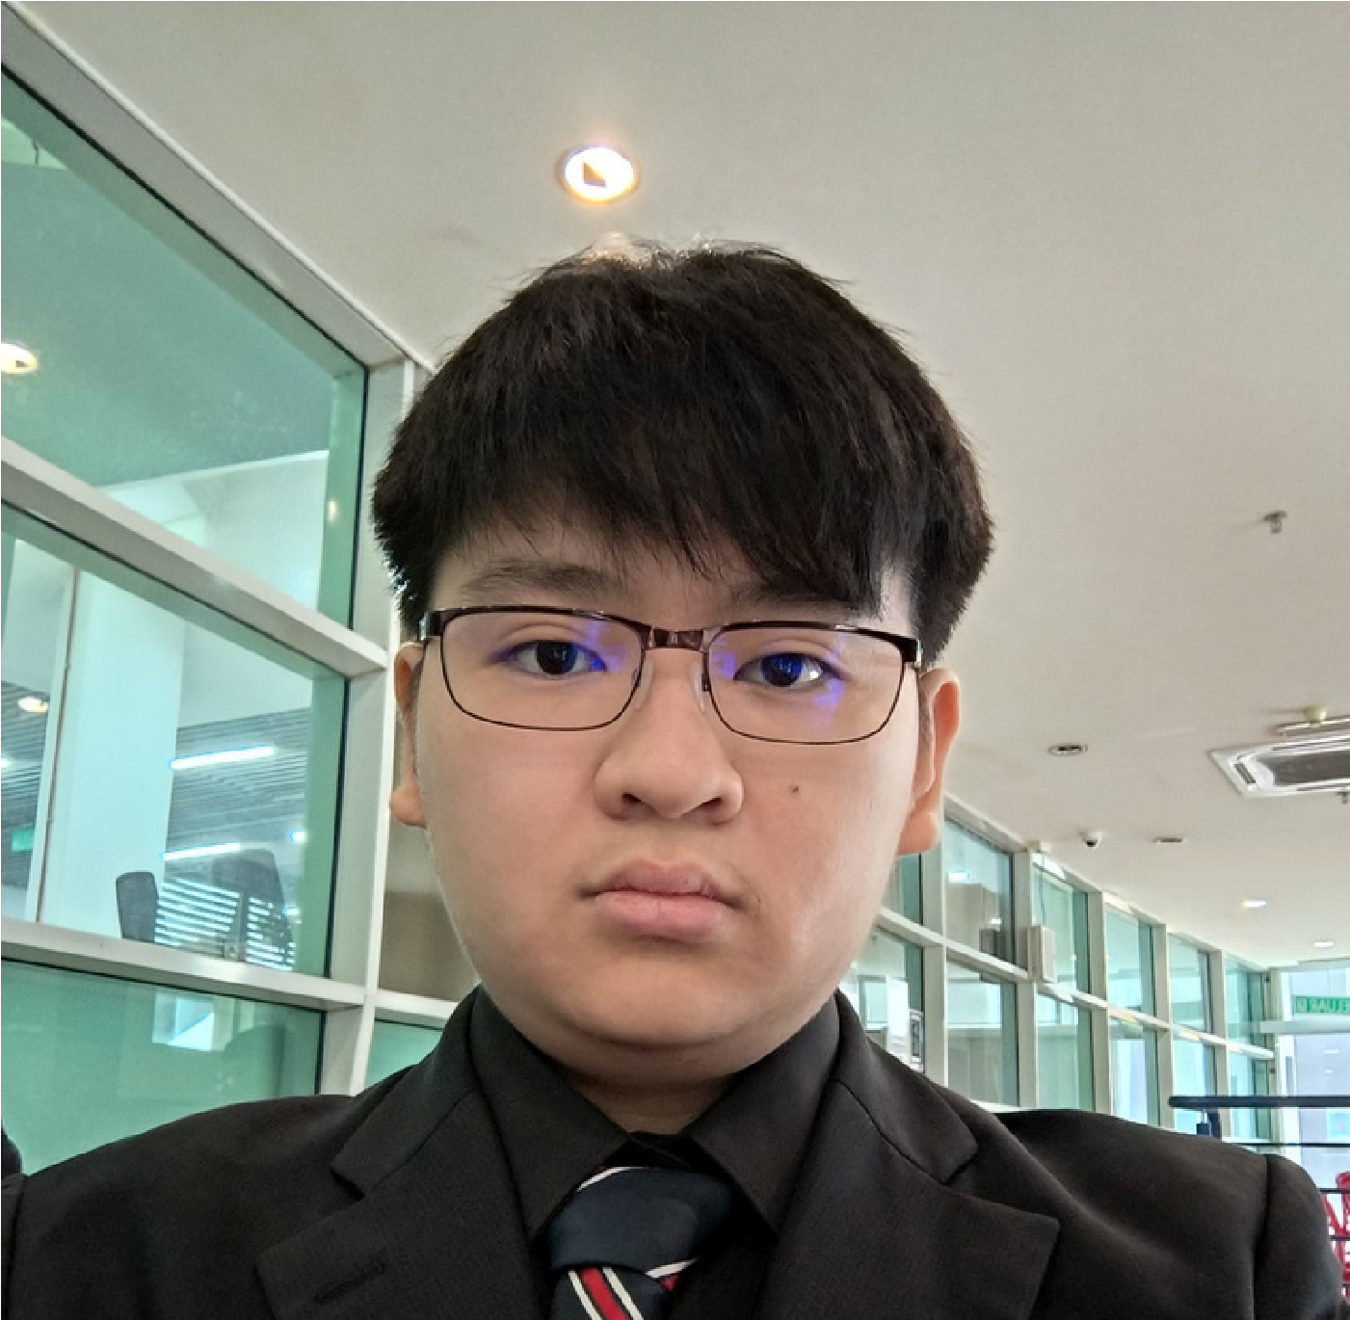

NAME: LIM WEI XIAN

ID:123110298

FROM: JOHOR BAHRU

This project taught me about how to manage a team, and how to find resources to make a project. For completing this project, I have learned some simple coding skills, and I am satisfied for my project.

In the project, I think better CSS and HTML skills can make our project better.

Goh Dilei

1231200740

Muar, Johor

I think that our project would help the freshies to know our

school and settle the problems they meet.

We could develop more function in our website and hear the needs what they need to know.



NAME: LEW YAN LI

ID:1231101285

FROM: MASAI,JOHOR

This project taught me about teamwork.

In the project, I improved my ability to complete tasks within a limited time.



**NAME: SIM LUI AN**

ID:1231202153

FROM: SKUDAI, JOHOR

I THINK THIS PROJECT LET ME LEARN

MANY THINGS.

I CAN LEARN MORE SKILL TO

OPTIMIZATION OUR WEBPAGE.